Change Request Form

Change Request details
Change Request details
Change Request Title | Supplier Registration of ABMU/ MPAN mapping
Change Request Number | CR043
Originating Advisory / Working Group | DRG
Risk/issue reference | MHHS-DIN-651
Change Raiser | Mike Ceney, Elexon | Date raised: | 24/01/2024

For further guidance on how to complete this document please see the supporting Change Request Form Guidance for Programme Participants. The guidance will support raising a change and responding to a change request via Impact Assessment. The Change Raiser should consider sharing the draft Change Request Form with impacted programme parties, prior to submission to PMO. The guidance, as well as other key documents are referenced below and can be found via the MHHS website.

Change Request to be read in conjunction with:
MHHS Change Request Form Guidance for Programme Participants
MHHS Change Control Approach
MHHS Governance Framework
Ofgem’s MHHS Transition Timetable

Part A – Description of proposed change
Guidance – This section should be completed by the Change Raiser when raising the Change Request.

Part A – Description of proposed change
Issue statement:
(what is the issue that needs to be resolved by the change)
In order to correctly perform its calculations, MDS requires Suppliers to register their MPAN/ABMU Mapping.
Currently, they send a D0297 to HHDAs to provide the Mapping and can populate the SVA Metering Service Register for MSID Pairs where they are used in the Balancing Mechanism using the P0278 and self-service via ELEXON Kinnect.
This doesn’t work in MHHS because;
- There are no HHDAs in MHHS TOM so the D0297 will need to be sent somewhere else
- The validation in Kinnect only supports instances where both export and import are with a single supplier as per current Operating Model
There is a gap in the Design and no way for Participants to provide the data to MDS.
- A solution is needed that not only replaces the D0297 but also their validation and the processing of the D0294 and D0295 responses, as laid out in the Multiple BM Unit Processing Specification.

Description of change:
(what is the change you are proposing)
The current MHHS design is that the supplier sends a P0278 to map the Mpan to an associated ABMU or log into the Elexon Customer Portal. This would then be validated and passed to MDS to apply the consumption ABMU.
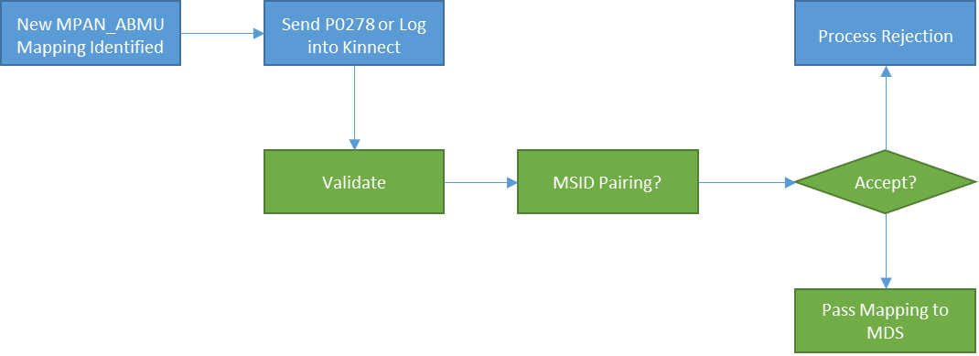

The proposed change is to replicate the existing legacy process whereby the supplier sends a D0297, which holds the MPAN_ABMU Mapping, to MDS. MDS will then validate the request and then either D0294 or D0295 to accept or reject the request.

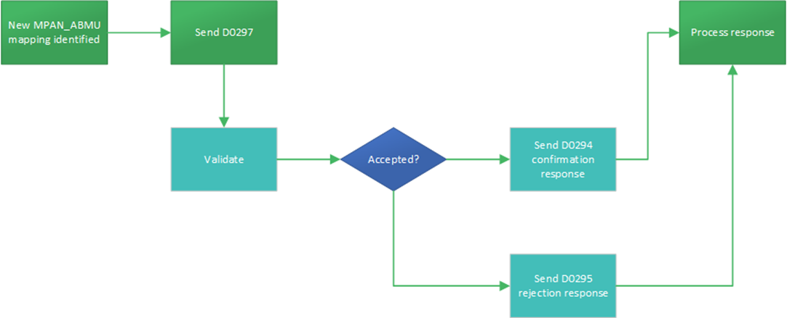

To facilitate this change, it requires a routing change for the flows mentioned, changing from HHDA to MDS as a recipient and sender.

Justification for change:
(please attach any evidence to support your justification)
MDS to carry out accurate calculations using accurate ABMU mapping. The current design would not fulfil the requirement
Currently circa 2000 Mpans are assigned to an ABMU, this equates to circa 13000 MWh, the current MHHS Design solution would only allocate circa 70 Mpans to an ABMU as the Kinnect solution only hold MSID pairings.
The failure to implement this change would have an impact on suppliers in settlement charges when consumption is allocated to the incorrect BMU. This issue would not be picked up during testing as this is not a defect in the design, it is a gap and a misrepresentation of how the process should have been designed
Consequences of no change:
(what is the consequence of no change)
Incorrect allocation of Additional Balancing Mechanism units, Circa 1900 Mpans would be incorrectly allocated to the Base BMU instead of the ABMU causing incorrect settlement invoices to the consumer.
Alternative options:
(What alternative options or mitigations that have been considered)
Creation of new MHHS interfaces to replicate the D0297, D0294 and D0295 to be sent via DIP
Changes to the validation in the Customer Portal and Elexon systems to accomated all MSID mappings not only MSID Import/Export pairings.
Risks associated with potential change:
(what risks related to implementation of the proposed change have been identified)
No risks identified at this stage

Stakeholders consulted on the potential change:
(Please document the stakeholders, or stats keholder groups that have been consulted to date on this change. The Change Raiser should consult with relevant programme parties in the drafting of the request, prior to submission to PMO).
Industry have been consulted on the change via the DIN process, this was discussed in a Design Resolution Group meeting held on the 12/01/2024
Target date by which a decision is required: | March 2024

Part B – Initial Impact of proposed change
Guidance – This section should be completed by the Change Raiser before being submitted to the MHHS PMO.
Please document the benefits of the change and to delivery of the programme objectives

What benefits does the change bring
(list the benefits of the change and how this improves the business case)
MDS to carry out calculations/aggregation using accurate ABMU mapping, closing a gap impacting circa 1900 Mpans

Programme Objective | Benefit to delivery of the programme objective
To deliver the Design Working Group’s Target Operating Model (TOM) covering the ‘Meter to Bank’ process for all Supplier Volume Allocation Settlement meters | Yes
To deliver services to support the revised Settlement Timetable in line with the Design Working Group’s recommendation | None identified
To implement all related Code changes identified under Ofgem’s Significant Code Review (SCR) | None identified
To implement MHHS in accordance with the MHHS Implementation Timetable | None identified
To deliver programme capabilities and outcomes to enable the realisation of benefits in compliance with Ofgem’s Full Business Case | Accurate Settlement invoicing and the ability to correctly map Mpan to ABMU
To prove and provide a model for future such industry-led change programmes | None identified

Guidance – Please document the known programme parties and programme deliverables that may be impacted by the proposed change

Impacted areas | Impacted items
Impacted Parties | MHHSP – Code Drafting & Design  Suppliers  Elexon  Helix  Code Manager
Impacted Deliverables | METH007 MDS Method Statement,  BRS008 MDS Requirements,  BRS004 Supplier Overview,  DES196 D-Flow and Interface Mapping  BSCP15- BM Unit Registration  Multiple BM Unit Instruction Processing Specification document
Impacted Milestones | None Identified

Note – Please refer to MHHS DEL174 Change Request Guidance for Programme Participants for information on how to score the initial assessment.

Initial assessment
Necessity of change |  | Expected lead time
Rationale of change |  | Expected implementation window
Expected change impact

Guidance – Please include a reference and link to any additional documentation which the change relates to.
Change Request to be read in conjunction with:
Title | Reference

Part C.1 – Summary of Impact Assessment

Note – This section will be completed initially by the Change Raiser and then by Programme Participants as part of the full Impact Assessment.

All Impact Assessment responses will be considered public and non-confidential unless otherwise marked. If there are any specific elements of the response (e.g. costs) that are confidential, please mark the specific sections as confidential rather than the response as a whole. The MHHS Programme will publish all Impact Assessment responses and redact any confidential information as noted.
Guidance – Programme Participants are required to:
- Respond with ‘Agree’, ‘Disagree’ or ‘Abstain’, deleting as appropriate. If the respondent agrees, they can provide additional evidence to further support the assessment. If the respondent disagrees or abstains, they should provide a detailed rationale as to why.

- Add any additional effects that have not already been identified. In doing so, they should provide as much detail as possible to allow a robust assessment to be made.

- Proceed to Part C.2 for Impact Assessment Recommendation response once completed.

Part C.1 – Summary of Impact Assessment (complete as appropriate)
Effect on benefits
No effects identified on the benefits
<Delete as appropriate>: Agree Disagree Abstain
Impact Assessment respondents to add supporting commentary to support their selection. Where possible, Impact Assessment respondents to identify and describe any further impacts.
Impact Assessment respondents should consider and provide detail of any additional effect e.g. whether there will be an impact on when a benefit will be realised; who will realise the benefit; the extent to which the benefit will be realised.
Where possible, contextual information should be included e.g. the benefit will be delayed by X weeks; the change means Y population will also realise the benefit.
Effect on consumers
The correct allocation of ABMUs will ensure the correct costs are applied

<Delete as appropriate>: Agree Disagree Abstain
Impact Assessment respondents to add supporting commentary to support their selection. Where possible, Impact Assessment respondents to identify and describe any further impacts.
Impact Assessment respondents should consider and provide detail of any additional effect e.g. whether there will be an impact on service delivery to consumers; will there be a cost impact to consumers; will there be a choice impact to consumers?
Where possible, contextual information should be included e.g. what is the scale of the effect? Will the effect be permanent?
Effect on schedule
No effect identified to the schedule

<Delete as appropriate>: Agree Disagree Abstain
Impact Assessment respondents to add supporting commentary to support their selection. Where possible, Impact Assessment respondents to identify and describe any further impacts.
Impact Assessment respondents should consider and provide detail of any additional effect e.g. will the schedule/milestones be directly impacted; will the schedule/milestones be indirectly impacted.
Where possible, contextual information should be included e.g. the change will delay the project by X days; the change will require additional resource to complete (though detail resource in resource section); the delay can/cannot be recovered by condensing Y activity.
Effect on costs
If this Change is not approved and actioned the incorrect allocation of consumption to the correct ABMU would have a cost impact to suppliers and consumers.
<Delete as appropriate>: Agree Disagree Abstain
Impact Assessment respondents to add supporting commentary to support their selection. Where possible, Impact Assessment respondents to identify and describe any further impacts.
Impact Assessment respondents should consider and provide detail of any additional effect e.g. will the change cause a loss of income; will the change cause additional cost; will the change cause a reprofiling of cost?
Where possible, contextual information should be included e.g. whether it is capital or operating expenditure that will be affected; what period costs will be affected in; what the rough order of magnitude of the cost impact will be and if organisation will be able to absorb it?
Effect on resources
Small change to Helix systems to accomadate receiving and sending of the mention data flows and mapping of Mpan to BM/ABMU

<Delete as appropriate>: Agree Disagree Abstain
Impact Assessment respondents to add supporting commentary to support their selection. Where possible, Impact Assessment respondents to identify and describe any further impacts.
Impact Assessment respondents should consider and provide detail of any additional effect e.g. will there be an impact on tools or equipment; will there be an impact on staff capacity; will there be an impact on staff skills or capability?
Where possible, contextual information should be included e.g. the change will require X additional staff for Y period of time; the change requires Z training or support.
Effect on contract
None

<Delete as appropriate>: Agree Disagree Abstain
Impact Assessment respondents to add supporting commentary to support their selection. Where possible, Impact Assessment respondents to identify and describe any further impacts.
Impact Assessment respondents should consider and provide detail of any additional effect e.g. whether there will be an impact on contracts with sub-contractors; whether there will be an impact on contracts with vendors; whether there will be an impact on contracts with regulators/ESO.
Where possible, contextual information should be included e.g. the changes will require new contracts to be created; the changes will variations to existing contracts; the changes will affect ability to meet contract requirements.
Risks
Risk to settlement costs if proposed solution is not agreed and implemented

<Delete as appropriate>: Agree Disagree Abstain
Impact Assessment respondents to add supporting commentary to support their selection. Where possible, Impact Assessment respondents to identify and describe any further impacts.
Impact Assessment respondents should consider and provide detail of any additional effect e.g. will existing risks be affected; will new risks be created?
Where possible, contextual information should be included e.g. the change will affect the likelihood of a risk occurring, the change will affect the impact the risk would have, the change will require additional controls and mitigation.

Part C.2 – Impact Assessment Recommendation

Note – This section must be completed initially by the Change Raiser and then by Programme Participants as part of the full Impact Assessment.
Guidance – The primary reporting metric of the Impact Assessment is the recommendation response. The consolidated response will be presented to the relevant governance group(s) and decision maker(s) with the totals for ‘Agree’, ‘Disagree’ or ‘Abstain’. As such, please ensure this section is completed before the form is returned to MHHS PMO. Provide detailed rationale and evidence in the commentary field.

Part C.2 – Impact Assessment Recommendation (mandatory)
Recommendation
Change Raiser to provide initial recommendation.
It is recommended by the Change Raiser the change is approved.
<Delete as appropriate>: Agree Disagree Abstain
Impact Assessment respondents to add supporting commentary to support their selection.

Impact assessment done by: <Name>

Guidance: If you are a third party responding on behalf of another Programme Participant, please state this in your response.

Impact assessment completed on behalf of: <Name>

Part D – Change approval and decision
Guidance: The approvals section will be completed by the MHHS PMO once the Impact Assessment has been reviewed.

Part D - Approvals
Decision authority level
<Based on the impact assessment, state who is required to make a decision concerning this change>

Guidance - This section will be completed by the MHHS PMO and Change Owner following the review of the impact assessment and decision reached by the SRO.

Part D – Change decision
Decision: |  | Date
Approvers:
Change Owner:
Action:
Changed Items | Pre-change version |  | Revised version

Part E – Implementation completion
Guidance - This section will be completed by the MHHS PMO at the end of the post-implementation process.

Part E – Implementation completion
Comment |  | Date

Guidance – The Closure Checklist in MHHS DEL175 Change Log must also be completed by MHHS PMO at this stage.

Checklist Completed | Completed by
Yes/No

Guidance – This section will be completed by the MHHS PMO at the end of the post-implementation process and should be used to add any appropriate references of the change once it has been completed.

References
Ref | Document number | Description

